Overall Performance

## Performance Chart:

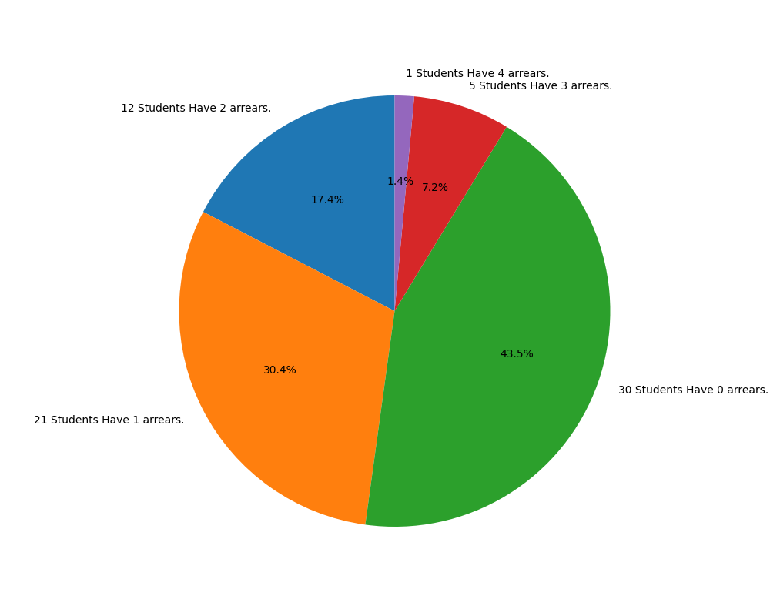

## Performance Summary:

### Student Have 4 arrears:

NARESH S

### Student Have 3 arrears:

KANNAN S  
LOKESH P  
SANTHOSH M  
SRIKANTH R  
SUJAN M S

### Student Have 2 arrears:

ABHISHEK K A  
ABIRAMI S  
GIRIDHARAN K  
GOWTHAM K  
KANNAN T  
PRIYADHARSHINI K  
SAKTHIVEL R  
SRIKANTH S  
UMA BHARATHI J  
VIMAL RAJ C  
JAHAN V  
NEHRU PRASAD S R

### Student Have 1 arrears:

AKASH S  
DHANASHALINI S  
DHANESHA A S  
GAYATHRI J M  
GUKAN R  
HANEEN S  
KARTHICK V  
KIRUBAKARAN P  
LAKSHANA S S  
MANOJKUMAR K  
MEHANDHIGA M  
RANJITHKUMAR S  
SABARI NATHAN V  
SEENIVASAN G  
SEVVELKARAN PALANI  
VETRIVEL  
SIBIKA S  
SWATHI V  
SWETHA V  
VARSHINI R R  
HARIHARAN C  
THANARAJ S

### Student Have 0 arrears:

AMBIRTHA N  
AMITHA KANISHMA J  
BALA SOWMIYA G  
BAVADHARANI C  
CHANDRU J  
DEVADHARSHINI K  
DHANUSHIKA S  
DHARANI S  
DINESH T  
DINESH RAM S  
DIVYA D  
HARI PRASANTH S  
JASWIN M  
KIRTHIKA S S  
KOUSHIK R  
KOWSIKA A  
KUMARESAN K R  
MALLISAVITHA M S K  
MERINKANTH N  
MOHAMMED ABDULLA A  
NIKITHA A  
PIRTHIKA P N  
PRIYADHARSHINI M  
RESHI S T  
SANDHIYA R  
SHANKAR D  
SHRINIDHI S  
SRIKAANTH V S  
YOGESWARI R  
VIMALRAJ P